Pip install allure-pytest

Convert Json files to HTML report

Install Java 8+

Install Node js report

Install allure command Line tool

npm install -g allure –commandline - -save-dev

Java check:

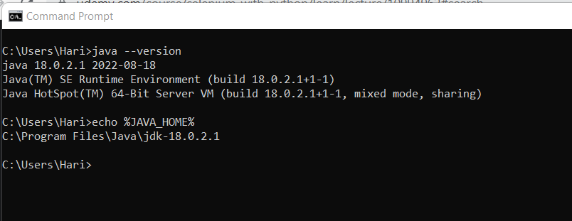

Download Node js:

<https://nodejs.org/en/download/>

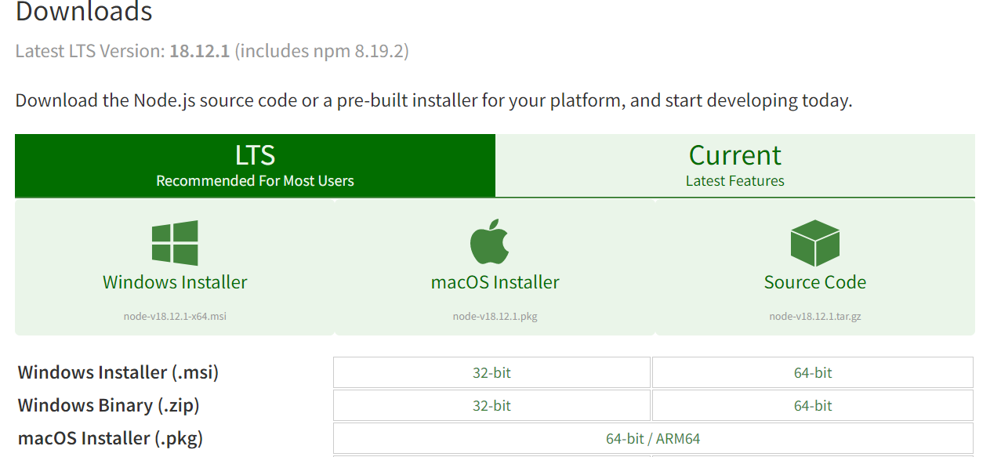

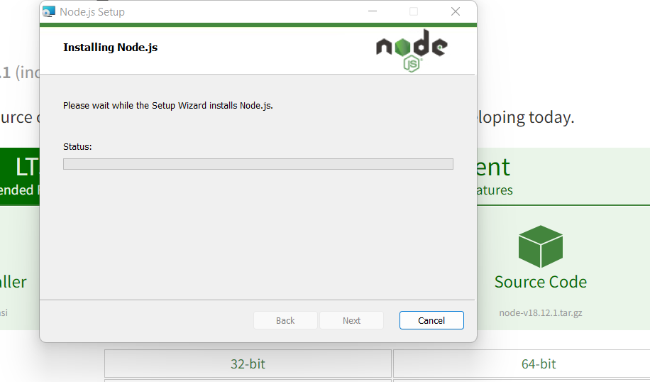

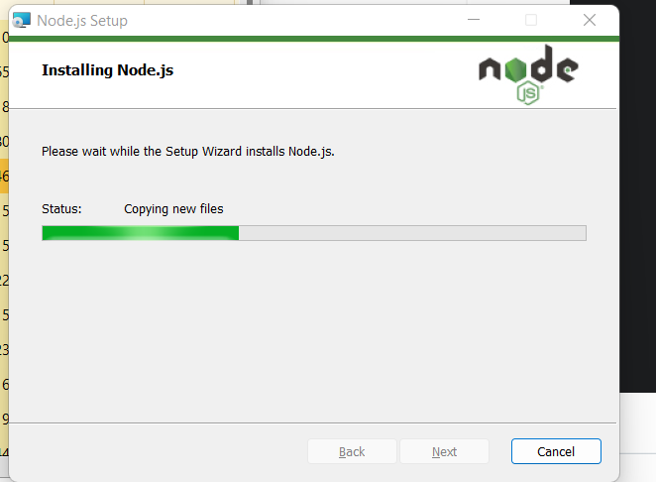

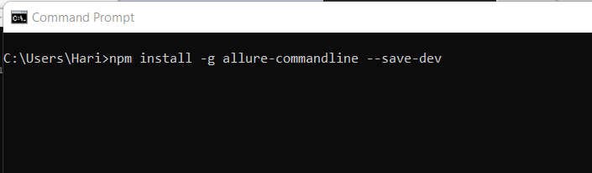

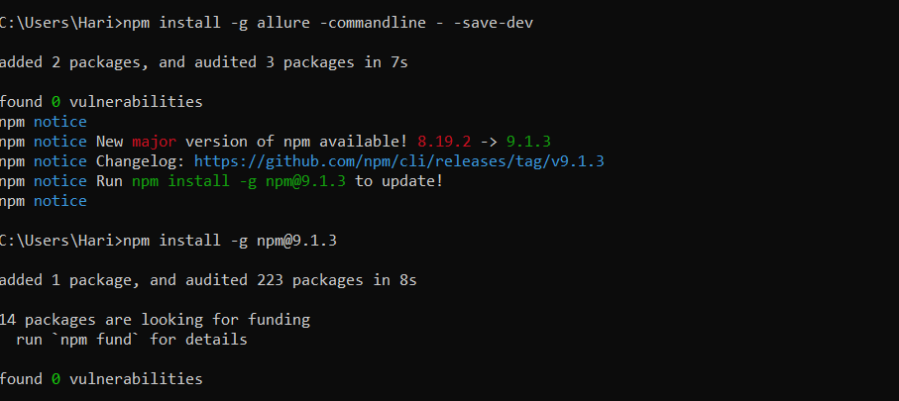

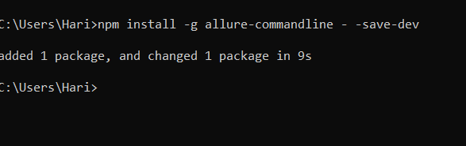

Cmd 2: allure

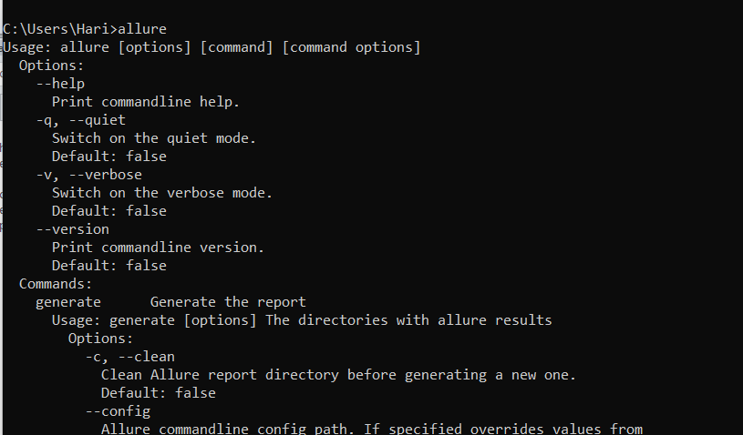

Command for execution:



Json reports:

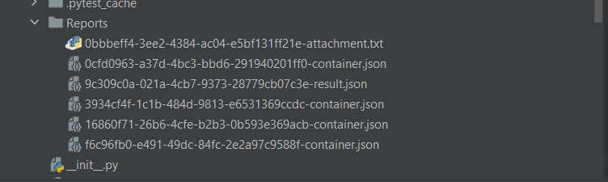



Allure reporting:

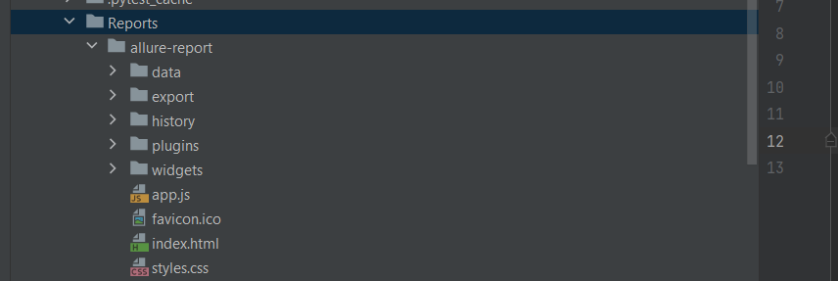

**Report 1**

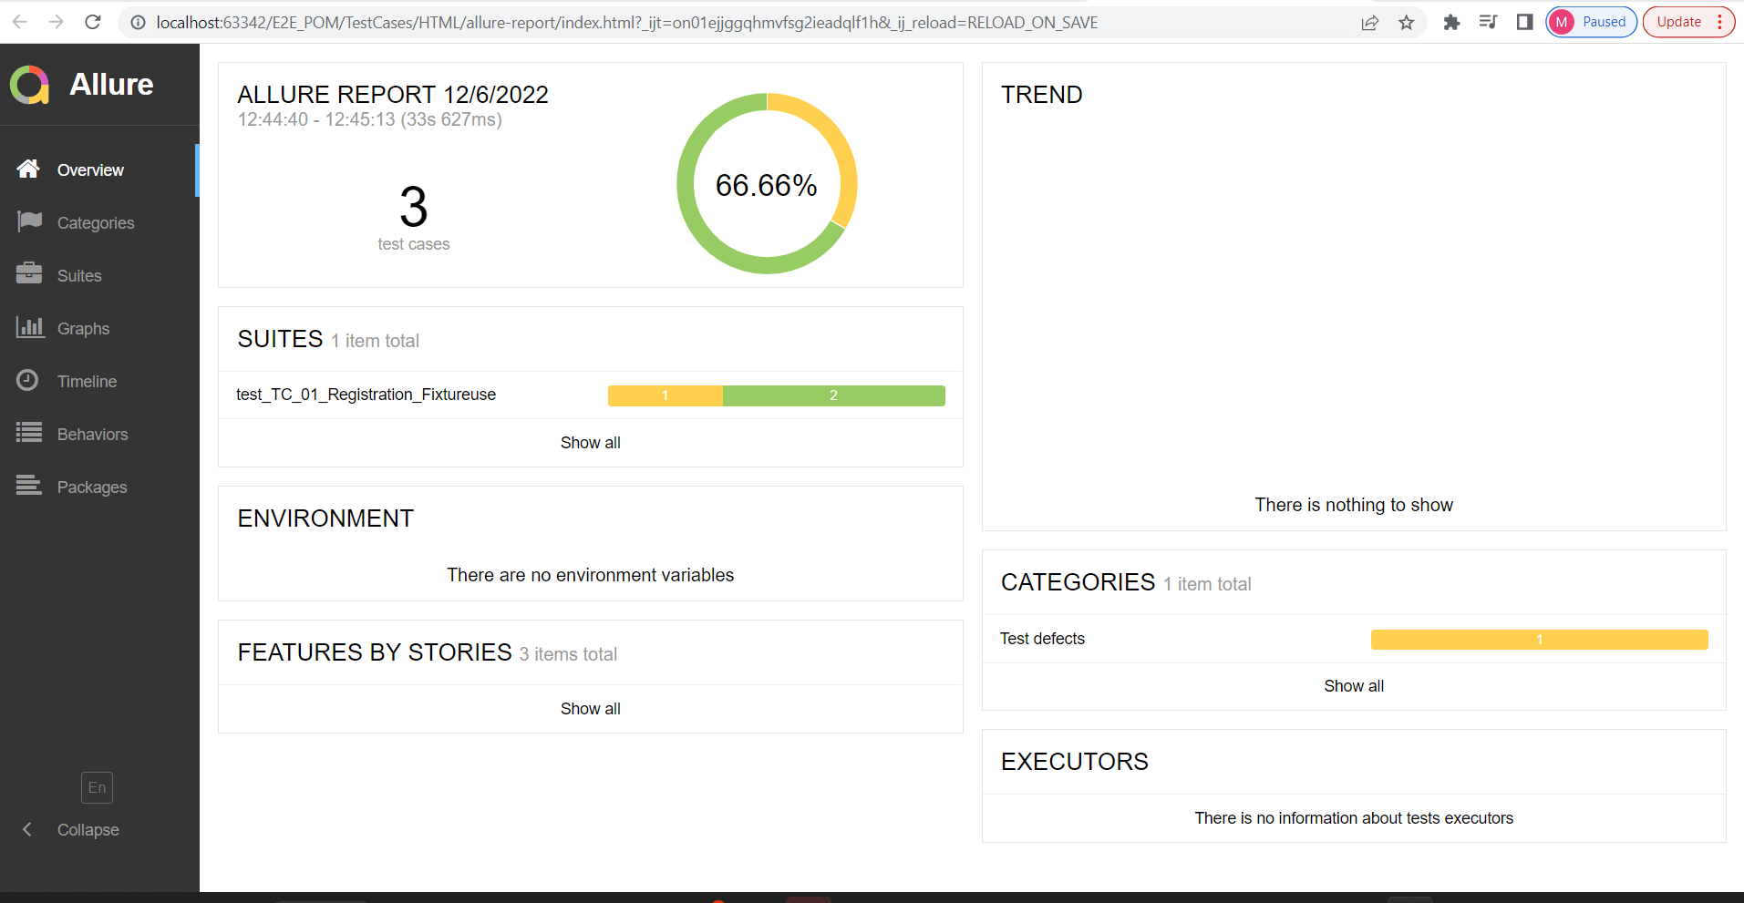

**Report 2:**

